NIGIRI SUSHI (BF)

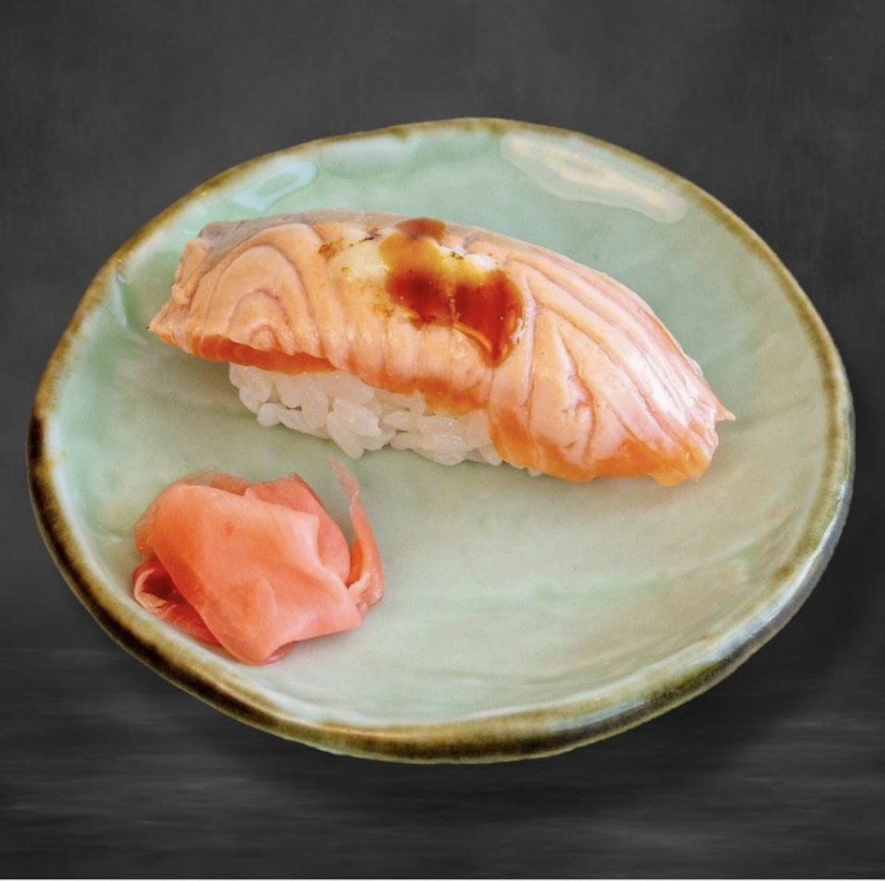

Sake Aburi (BF) Sake Mentai Aburi (BF) Sake Sushi (BF)

Sake Tsurai Mayo Sushi (BF) Sake Truffle Sushi (BF) Sake Mayo Ball (BF)

Hamachi Sushi (BF) Maguro Sushi (BF) Mekajiki Sushi (BF)

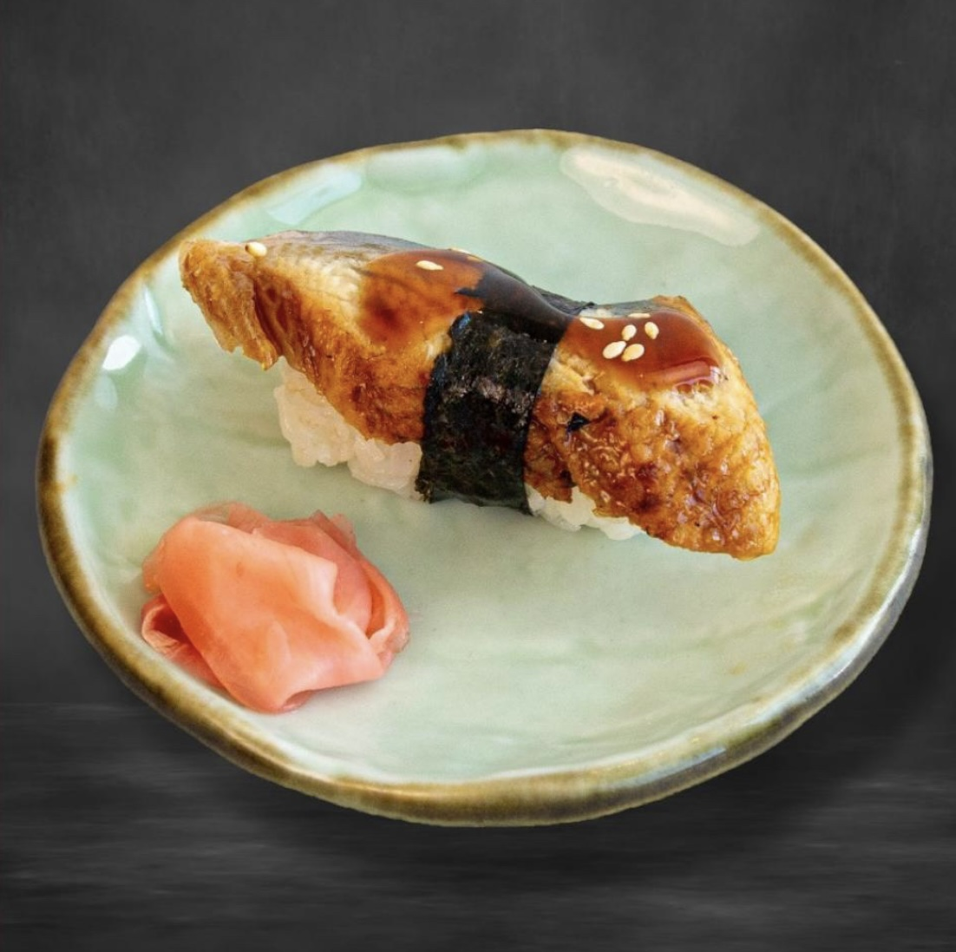

Tako Sushi (BF) Unagi Sushi (BF) Inari Sushi (BF)

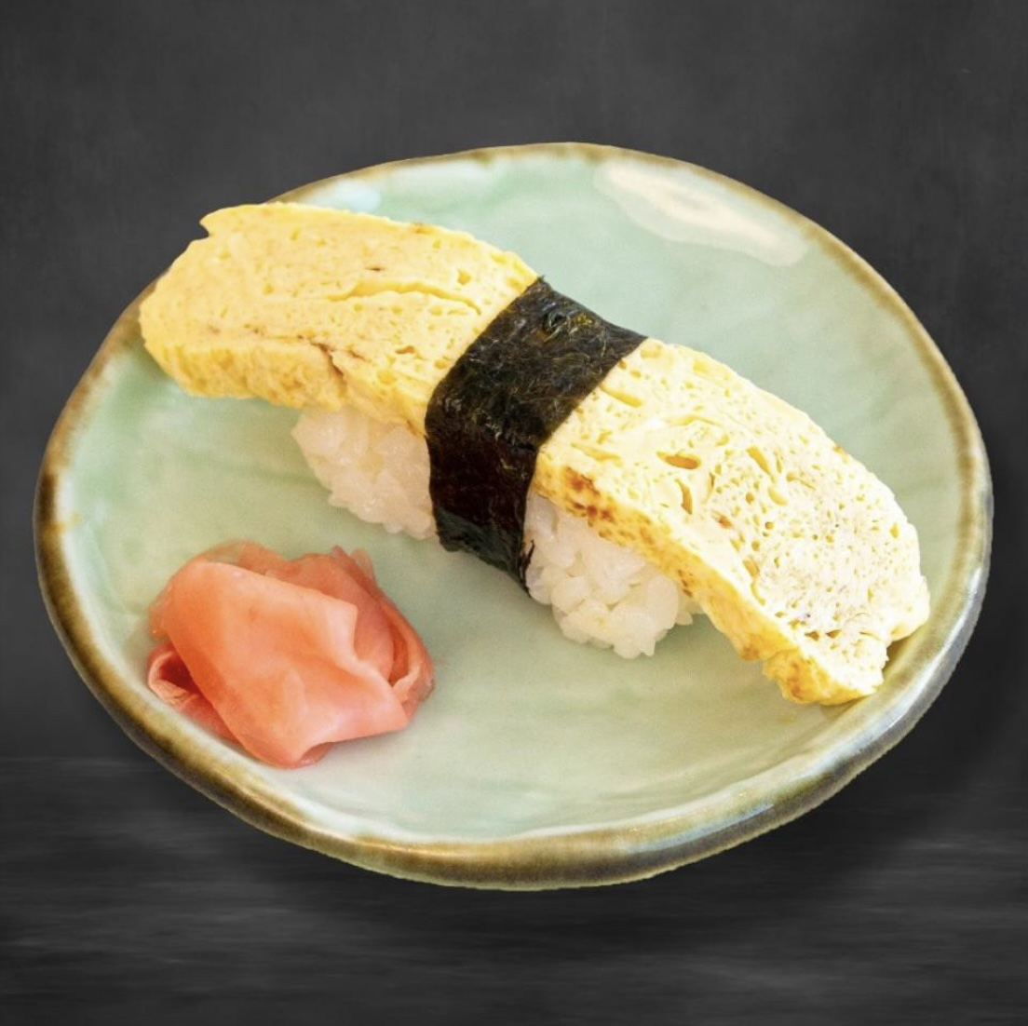

Tamago Sushi (BF) Ebi Sushi (BF) Ikura Sushi (BF)

Tobikko Sushi (BF) Maguro Mayo Sushi (BF) Negitoro Sushi (BF)

Ise Ebi Sarada Sushi (BF) Suitokon Sushi (BF)